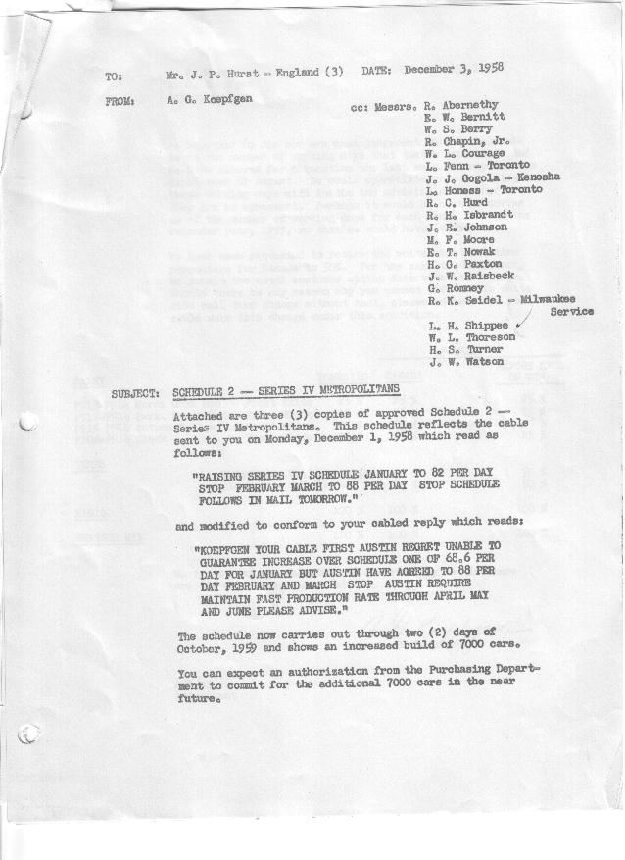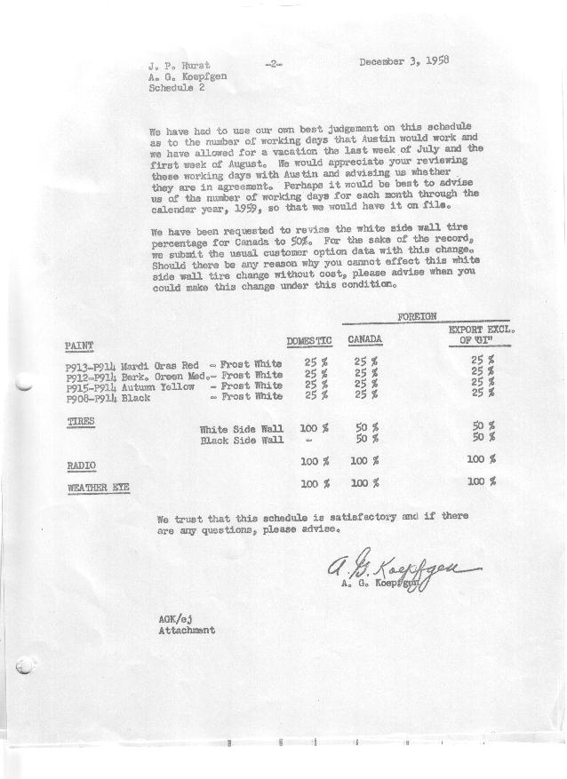

FORM AM 1262 Page 1 of 2 APPROVED R. Abernethy (signed) DATE 12-3-58

SCHEDULE NO. ______2 ___ DATE 12-3-58 MONTHLY BUILDING SCHEDULE APPROVED R. W.Chapin Jr. (signed) DATE_ 12/4/58 _
REVISION NO. _______ __ ____ DATE PRODUCT APPROVED E.W.Bernitt (signed) DATE _ 12/8/58 ____
SERIES IV 1500 c.c. ENGINE
METROPOLITAN SERIES CARS – AUSTIN MOTORS CO., LTD, ENGLAND
DESCRIPTION | BUILT  ◻ACT◻ EST  THRU | FIRM BUILDING SCHEDULE  (FABRICATED MATERIAL RELEASE) |  |  |  |  |  |  |  |  |  |  |  |  |  |  | TENTATIVE SCHEDULE  (RAW MATERIAL RELEASED) |  |  | GRAND  TOTAL
DESCRIPTION | BUILT  ◻ACT◻ EST  THRU | MONTH JANUARY 1959  DAYS 15 |  |  | MONTH FEBRUARY  DAYS 20 |  |  | MONTH MARCH  DAYS 20 |  |  | MONTH APRIL  DAYS 20 |  |  | MONTH MAY  DAYS 19 |  |  | MONTH JUNE  DAYS 22 |  |  | GRAND  TOTAL
DESCRIPTION | BUILT  ◻ACT◻ EST  THRU | DAILY | MONTH | CUM’L  TOTAL | DAILY | MONTH | CUM’L  TOTAL | DAILY | MONTH | CUM’L  TOTAL | DAILY | MONTH | CUM’L  TOTAL | DAILY | MONTH | CUM’L  TOTAL | DAILY | MONTH | CUM’L TOTAL | GRAND  TOTAL
DOMESTIC LHD:
Hard-Top |  |  | 673 | 673 |  | 1209 | 1882 |  | 1134 | 3016 |  | 1134 | 4150 |  | 1067 | 5217 |  | 1274 | 6491
Soft-Top |  |  | 229 | 229 |  | 403 | 632 |  | 378 | 1010 |  | 378 | 1388 |  | 356 | 1744 |  | 425 | 2169
Total U.S. |  | 60.1 | 902 | 902 | 80.6 | 1612 | 2514 | 75.6 | 1512 | 4026 | 75.6 | 1512 | 5538 | 74.9 | 1423 | 6961 | 77.2 | 1699 | 8660
Over/(Under) Schedule 1, R.1 |  |  | 33 | 33 |  | 300 | 333 |  | 300 | 633 |  | 300 | 933 |  | 285 | 1218 |  | 777 | 1995
FOREIGN:
EXPORT LHD Hard-Top |  |  | 15 | 15 |  | 30 | 45 |  | 30 | 75 |  | 30 | 105 |  | 30 | 135 |  | 30 | 165
Soft-Top |  |  | 5 | 5 |  | 10 | 15 |  | 10 | 25 |  | 10 | 35 |  | 10 | 45 |  | 10 | 55
Total Export LHD |  |  | 20 | 20 |  | 40 | 60 |  | 40 | 100 |  | 40 | 140 |  | 40 | 180 |  | 40 | 220
RHD Hard Top |  |  | 5 | 5 |  | 7 | 12 |  | 7 | 19 |  | 7 | 26 |  | 7 | 33 |  | 7 | 40
Soft Top |  |  | 2 | 2 |  | 3 | 5 |  | 3 | 8 |  | 3 | 11 |  | 3 | 14 |  | 3 | 17
Total Export RHD |  |  | 7 | 7 |  | 10 | 17 |  | 10 | 27 |  | 10 | 37 |  | 10 | 47 |  | 10 | 57
Total Export LHD & RHD |  | 1.8 | 27 | 27 | 2.5 | 50 | 77 | 2.5 | 50 | 127 | 2.5 | 50 | 177 | 2.7 | 50 | 227 | 2.3 | 50 | 277
Over/(Under) Schedule 1, R.1 |  |  | (33) | (33) |  | (10) | (43) |  | (10) | (53) |  | (10) | (63) |  | (10) | (73) |  | (10) | (83)
CANADA Hard-Top |  |  | 90 | 90 |  | 85 | 175 |  | 150 | 325 |  | 150 | 475 |  | 180 | 655 |  | 175 | 830
Soft-Top |  |  | 10 | 10 |  | 15 | 25 |  | 50 | 75 |  | 50 | 125 |  | 20 | 145 |  | -0- | 145
Total Canada |  | 6.7 | 100 | 100 | 5.0 | 100 | 200 | 10.0 | 200 | 400 | 10.0 | 200 | 600 | 10.5 | 200 | 800 | 7.9 | 175 | 975
Over/(Under) Schedule 1, R.1 |  |  | -0- | -0- |  | -0- | -0- |  | -0- | -0- |  | -0- | -0- |  | -0- | -0- |  | -0- | -0-
Total Foreign |  | 8.5 | 127 | 127 | 7.5 | 150 | 277 | 12.5 | 250 | 527 | 12.5 | 250 | 777 | 13.2 | 250 | 1027 | 10.2 | 225 | 1252
Over/(Under) Schedule 1, R.1 |  |  | (33) | (33) |  | (10) | (43) |  | (10) | (53) |  | (10) | (63) |  | (10) | (73) |  | (10) | (83)
GRAND TOTALS
Hard-Top |  | 52.2 | 783 | 783 | 66.6 | 1331 | 2114 | 66.0 | 1321 | 3435 | 66.0 | 1321 | 4756 | 67.6 | 1284 | 6040 | 67.5 | 1486 | 7526
Soft-Top |  | 16.4 | 246 | 246 | 21.5 | 431 | 677 | 22.1 | 441 | 1118 | 22.1 | 441 | 1559 | 20.5 | 389 | 1948 | 19.9 | 438 | 2386
Total |  | 68.6 | 1029 | 1029 | 88.1 | 1762 | 2791 | 88.1 | 1762 | 4553 | 88.1 | 1762 | 6315 | 88.1 | 1673 | 7988 | 87.4 | 1924 | 9912
Over/(Under) Schedule 1, R.1 |  |  | -0- | -0- |  | 290 | 290 |  | 290 | 580 |  | 290 | 870 |  | 275 | 1145 |  | 767 | 1912

FORM AM 1262 Page 2 of 2 APPROVED R. Abernethy (signed) DATE 12-3-58

SCHEDULE NO. ______2 ___ DATE 12-3-58 MONTHLY BUILDING SCHEDULE APPROVED R. W.Chapin Jr. (signed) DATE_ 12/4/58 _
REVISION NO. _______ __ ____ DATE PRODUCT APPROVED E.W.Bernitt (signed) DATE _ 12/8/58 ____
SERIES IV 1500 c.c. ENGINE
METROPOLITAN SERIES CARS – AUSTIN MOTORS CO., LTD, ENGLAND
DESCRIPTION | BUILT  ◻ACT◻ EST  THRU | FIRM BUILDING SCHEDULE  (FABRICATED MATERIAL RELEASE) |  |  |  |  |  |  |  |  |  |  |  |  |  |  | TENTATIVE SCHEDULE  (RAW MATERIAL RELEASED) |  |  | GRAND  TOTAL
DESCRIPTION | BUILT  ◻ACT◻ EST  THRU | MONTH JULY  DAYS 18 |  |  | MONTH AUGUST  DAYS 16 |  |  | MONTH SEPTEMBER  DAYS 22 |  |  | MONTH OCTOBEr  DAYS 2.2 |  |  | MONTH  DAYS |  |  | MONTH  DAYS |  |  | GRAND  TOTAL
DESCRIPTION | BUILT  ◻ACT◻ EST  THRU | DAILY | MONTH | CUM’L  TOTAL | DAILY | MONTH | CUM’L  TOTAL | DAILY | MONTH | CUM’L  TOTAL | DAILY | MONTH | CUM’L  TOTAL | DAILY | MONTH | CUM’L  TOTAL | DAILY | MONTH | CUM’L TOTAL | GRAND  TOTAL
DOMESTIC LHD:
Hard-Top |  |  | 1068 | 7559 |  | 974 | 8533 |  | 1367 | 9900 |  | 144 | 10044
Soft-Top |  |  | 356 | 2525 |  | 325 | 2850 |  | 456 | 3306 |  | 48 | 3354
Total U.S. |  | 79.1 | 1424 | 10084 | 81.2 | 1299 | 11383 | 82.8 | 1823 | 13206 | 87.4 | 192 | 13398
Over/(Under) Schedule 1, R.1 |  |  | 1424 | 3419 |  | 1299 | 4718 |  | 1823 | 6541 |  | 192 | 6733
FOREIGN:
EXPORT LHD Hard-Top |  |  | 30 | 195 |  | 30 | 225 |  | 30 | 255 |  | -0- | 255
Soft-Top |  |  | 10 | 65 |  | 10 | 75 |  | 10 | 85 |  | -0- | 85
Total Export LHD |  |  | 40 | 260 |  | 40 | 300 |  | 40 | 340 |  | -0- | 340
RHD Hard Top |  |  | 7 | 47 |  | 7 | 54 |  | 7 | 61 |  | -0- | 61
Soft Top |  |  | 3 | 20 |  | 3 | 23 |  | 3 | 26 |  | -0- | 26
Total Export RHD |  |  | 10 | 67 |  | 10 | 77 |  | 10 | 87 |  | -0- | 87
Total Export LHD & RHD |  | 2.7 | 50 | 327 | 3.1 | 50 | 377 | 2.3 | 50 | 427 |  | -0- | 427
Over/(Under) Schedule 1, R.1 |  |  | 50 | (33) |  | 50 | 17 |  | 50 | 67 |  | -0- | 67
CANADA Hard-Top |  |  | 100 | 930 |  | 50 | 980 |  | 50 | 1030 |  | -0- | 1030
Soft-Top |  |  | -0- | 145 |  | -0- | 145 |  | -0- | 145 |  | -0- | 145
Total Canada |  | 5.6 | 100 | 1075 | 3.1 | 50 | 1125 | 2.3 | 50 | 1175 |  | -0- | 1175
Over/(Under) Schedule 1, R.1 |  |  | 100 | 100 |  | 50 | 150 |  | 50 | 200 |  | -0- | 200
Total Foreign |  | 8.3 | 150 | 1402 | 6.2 | 100 | 1502 | 4.6 | 100 | 1602 |  | -0- | 1602
Over/(Under) Schedule 1, R.1 |  |  | 150 | 67 |  | 100 | 167 |  | 100 | 267 |  | -0- | 267
GRAND TOTALS
Hard-Top |  | 66.9 | 1205 | 8731 | 66.3 | 1061 | 9792 | 66.1 | 1454 | 11246 | 65.4 | 144 | 11390
Soft-Top |  | 20.5 | 369 | 2755 | 21.1 | 338 | 3093 | 21.3 | 469 | 3562 | 22.0 | 48 | 3610
Total |  | 87.4 | 1574 | 11486 | 87.4 | 1399 | 12885 | 87.4 | 1923 | 14808 | 87.4 | 192 | 15000
Over/(Under) Schedule 1, R.1 |  |  | 1574 | 3486 |  | 1399 | 4885 |  | 1923 | 6808 |  | 192 | 7000

